USER MANUAL
Party-wise brand details of stock items
InTelli Solutions
Karnal, Haryana, INDIA-132001
Telefone-+919813501438, +919991428000
E-mail-intallysolutions@gmail.com
Web-Site: - http://www.intallysolutions.com

© 2020InTelli Solutions. All rights reserved.

Tally, Tally 9, Tally9, Tally.ERP, Tally.ERP 9, Shoper, Shoper 9, Shoper POS, Shoper HO, Shoper 9 POS, Shoper 9 HO, TallyDeveloper, Tally.Server 9, Tally Developer, Tally. Developer 9, Tally.NET, Tally Development Environment, TallyPrime, TallyPrimeDeveloper, TallyPrime Server, Tally Extender, Tally Integrator, Tally Integrated Network, Tally Service Partner, TallyAcademy & Power of Simplicity are either registered trademarks or trademarks of Tally Solutions Pvt. Ltd. in India and/or other countries. All other trademarks are properties of their respective owners.
Version: InTelli Solutions/Horizontal and Vertical Lines in Reports/1.1/November 2020

Party-wise brand details of stock items/1.1
Introduction
In daily business, companies need to maintain brand name for their Stock Items, so that no two wholesalers get the same brand in a market, to make the market practical. In other words, it needs to maintain a different brand name for different party for a particular stock item.
With this module, User can Print multiple names or multiple brand for a stock items for his multiple Buyers and maintain stock for a single item.

Benefits
- Easy maintain of vouchers.
- Easy maintaining of creation of multiple vouchers in one go
What’s New?
New in Release 1.1: -
- Compatible with release 1.0.
Important!
Take back up of your company data before activating the Add-on.

Once you try / purchase an Add-on, follow the steps below to configure the Add-on and use it.
Setup Guide
- Update your license by going to Gateway of Tally F1: Help Settings License Manage License F5: Update
(In case you are using a multi-site account, you will need to configure TallyPrime to activate the Add-on for a particular site. Click here for the steps.)
- Shut down and Restart TallyPrime and open your company.
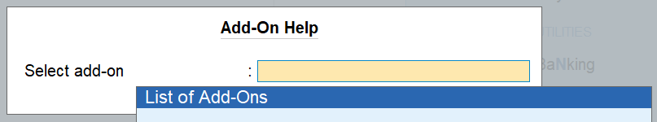
- Press Ctrl + Alt + H at any menu screen to open the user manual. Incase of multiple Add-on, Add-On Help screen will pop-up to select Add-on Manual.

- Activate the Add-on.

For TallyPrime Release 1.0
Go to Gateway of Tally F1: Help TDL & Add-On F6: Add-On Features. Alternatively, you may press CTRL + ALT + T from any menu to open TDL Management report and then press F6: Add-On Features

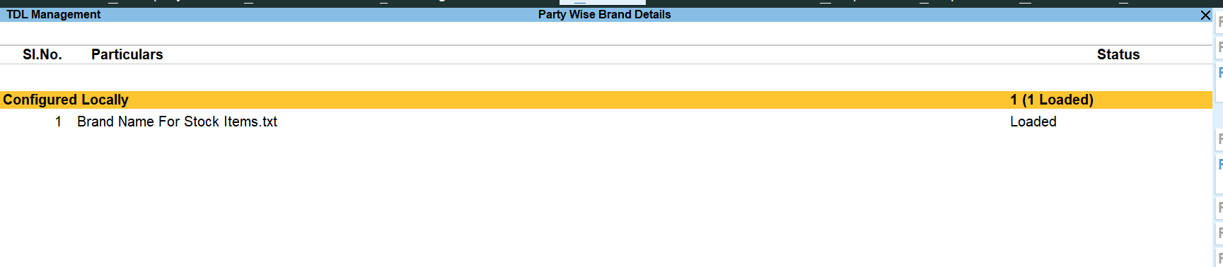
Set “Yes” to the option “Enable Brand Name For Stock Items”
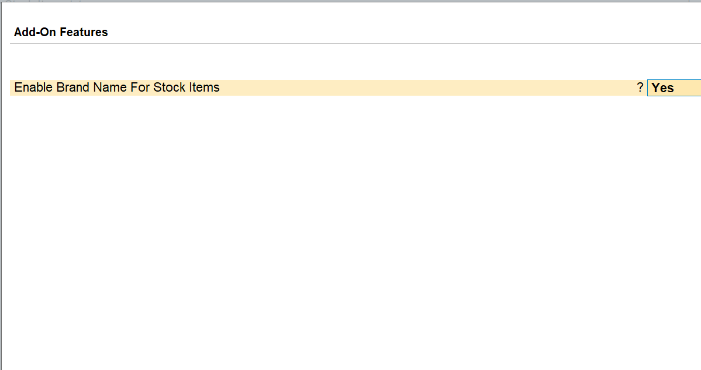

- Go to Gateway of tally Create Accounting Masters Create and create ledger
  - Set “Set Stock Item Brand names” to Yes
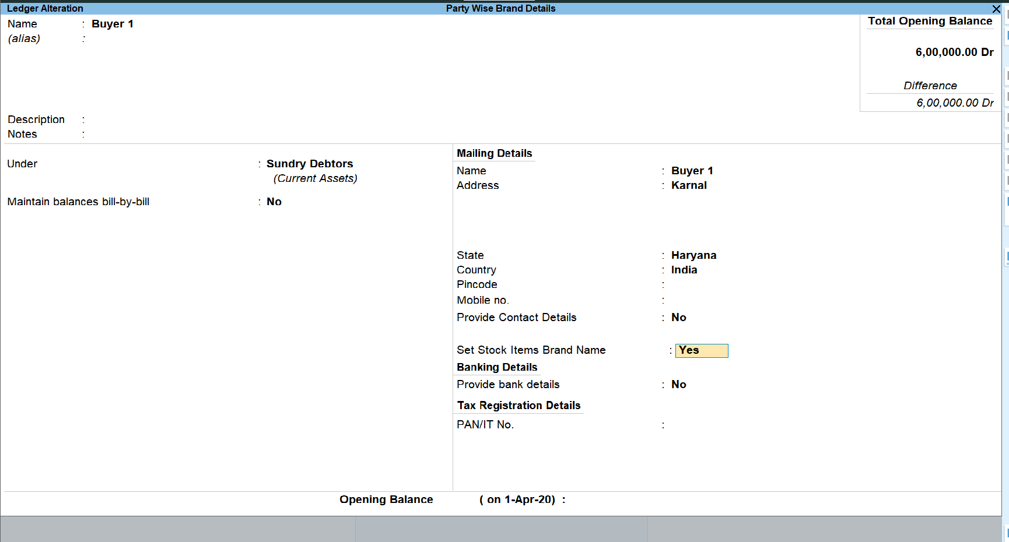

- Select stock items and enter their Brand Names for this party: -

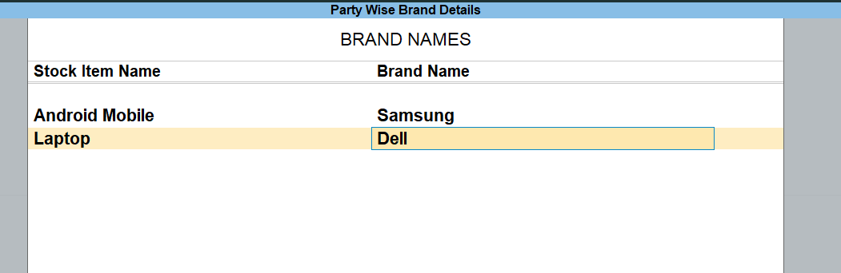

- Similarly enter brand names for different parties, you want to enter.
- Create sales voucher and select Party Name, and Stock Item Name as follows: -

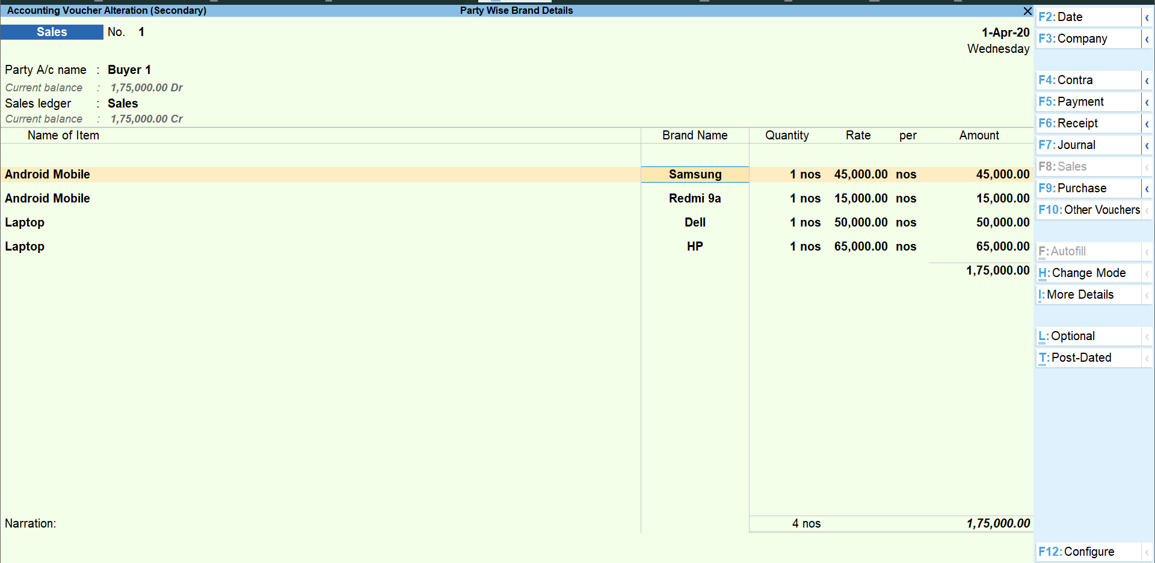

- Brand Names saved for the party automatically fetched and saved at voucher.

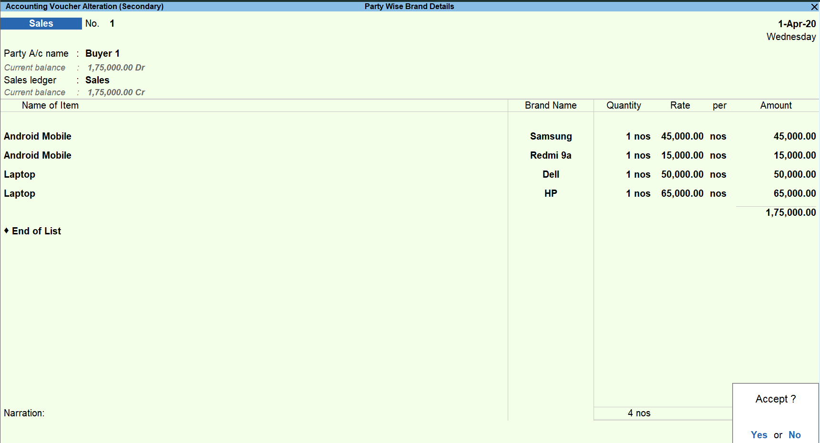

- Save the voucher and print the voucher with details.

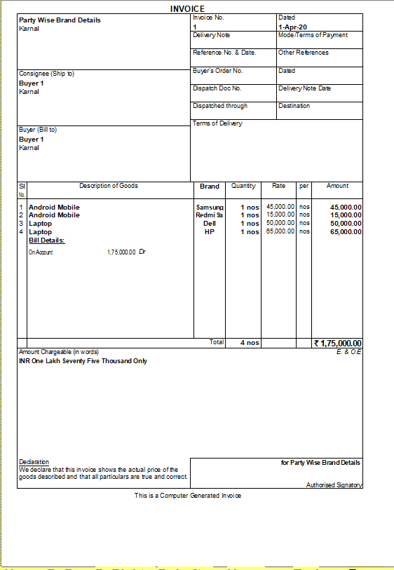

FAQ
Which version/release of TallyPrime does the add-on support?
This add-on will work only from TallyPrime Release 1.0

How will I get support for this add-on?
For any functional support requirements please do write to us on intallysolutions@gmail.com or call us at + 91-9813501438, +91-9991428000. Alternatively, you can send a support query to support@tallysolutions.com.

If I need some enhancements / changes to be incorporated for the add-on, whom should I contact?
Please to write to us on intallysolutions@gmail.com with your additional requirements and we will revert to you in 24 business hours.

Will new features added be available to us?
We offer one year availability of all support and new features free of cost. After one year, nominal subscription cost will be applicable to you to continue to get free support and updates.

What will happen after one year?
A subscription for a year has to be renewed for the Add-On. The cost would be 20% of the MRP prevailing at that time, of the Add-On.

I am using a multi-site. Can I use the same Add-on for all the sites?
No, one Add-on will work only for one site. You need to purchaseagain if you want to use the same Add-on for more sites.

How do I configure the add-ons for multi-site?
If you are a TallyPrime Multi site user, add the Add-on to the required site as follows:
  - Gateway of Tally F1: Help Settings License Manage Account. This shall open control centre on Tally Portal / Website
  - Go to TDL Management TDL Configuration Select the site’s default TDL
  - Under ‘Select TDL Account’, select the Add-on Name and Click on Create / Accept button.
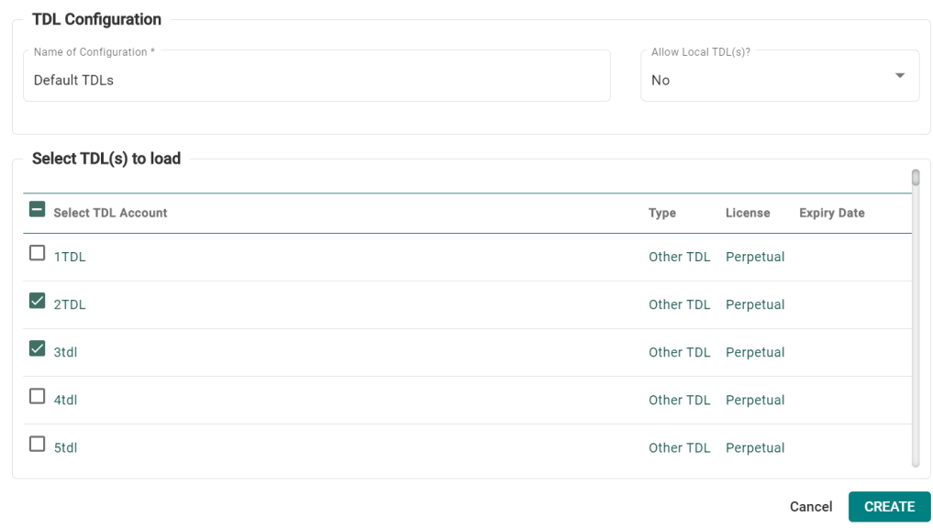
  - Update your license by going to Gateway of Tally F1: Help Settings License Manage License F5: Update

Note: To know or change the site’s default TDL configuration, go to Gateway of Tally F1: HelpSettings LicenseManage Account. In the webpage go to Account Management License Management and look at the Deploymentsection in the right side of the pane.)

If you face problems in configuring the add-on, click on this link to know more.
http://www.tallysolutions.com/website/html/solutions/how-to-configure.php

I have upgraded to a new TallyPrime Release. What will happen?
Normally, the add-on will work fine without any glitches. If you face problems with the Add-on, you can contact us for support.

TDL Management screen shows errors with the Add-on. What do I do?
Check whether the error is because of the Add-on or because of clashes between 2 TDLs (An add-on is also a TDL). In case of clashes, disable one or more TDLs and check which TDL has the error. If the Add-on has a problem, you can report it to us.

My Tally went into educational mode after installing the add-on. What do I do?
go to Gateway of Tally F1: Help Settings License Manage Account. In the webpage go to Account Management License Management and look at the Deployment section.Select Not Applicable for TDL Configuration and the Add-On is removed for the license. Now Update the license from the product.

How do I cross upgrade the Add-on from Silver to Gold Edition?
Go to F1: Help TallyShop. A web page for TallyShop shall open. Choose the add-on for which the edition needs to be changed.Update the license and restart Tally after download.

My Subscription for the Add-on has expired. How do I renew my subscription?
Go to F1: Help TallyShop. A web page for TallyShop shall open. Choose the add-on for which the subscription is required to be renewed.

Will this add-on work in remote session?
Yes, this add-on will work remotely.

