USER MANUAL
Brand wise ledger Price list
InTelli Solutions
Karnal, Haryana, INDIA-132001
Telefone-+919813501438, +919991428000
E-mail-intallysolutions@gmail.com
Web-Site: - http://www.intallysolutions.com

© 2020 InTelli Solutions. All rights reserved.

Tally, Tally 9, Tally9, Tally.ERP, Tally.ERP 9, Shoper, Shoper 9, Shoper POS, Shoper HO, Shoper 9 POS, Shoper 9 HO, TallyDeveloper, Tally.Server 9, Tally Developer, Tally. Developer 9, Tally.NET, Tally Development Environment, TallyPrime, TallyPrimeDeveloper, TallyPrime Server, Tally Extender, Tally Integrator, Tally Integrated Network, Tally Service Partner, TallyAcademy & Power of Simplicity are either registered trademarks or trademarks of Tally Solutions Pvt. Ltd. in India and/or other countries. All other trademarks are properties of their respective owners.

Version: InTelli Solutions/Brand wise ledger Price list /1.1/ November 2020

Brand wise ledger Price list/1.1
Introduction
There are so many manufactures that produces goods for other enterprises that cover marketing only using their own Brand. In this way, they manufacture the same product for different clients using different brands as per their specification and quality. So for all such type of dealer, they have to maintain different price list for different enterprises. With this add on, you can maintain brand wise stock items control with settled price list for different dealers on ledgers. You can also restrict selected stock items supply for every dealer on their ledger.
Benefits
- Easy maintain of brands and the prices for them.
- Easy maintaining of discount and MRP structures.
Important!
Take back up of your company data before activating the Add-on.

Once you try / purchase an Add-on, follow the steps below to configure the Add-on and use it.
Setup Guide
- Update your license by going to Gateway of Tally F1: Help Settings License Manage License F5: Update
(In case you are using a multi-site account, you will need to configure TallyPrime to activate the Add-on for a particular site. Click here for the steps.)
- Shut down and Restart TallyPrime and open your company.
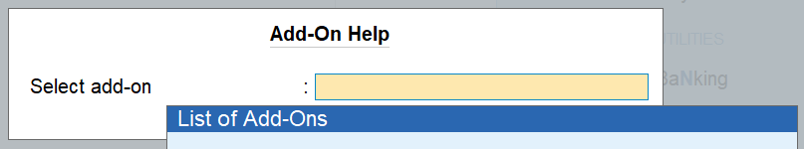
- Press Ctrl + Alt + H at any menu screen to open the user manual. In case of multiple Add-on, Add-On Help screen will pop-up to select Add-on Manual.

- Activate the Add-on.

For TallyPrime Release 1.0
Go to Gateway of Tally F1: Help TDL & Add-On F6: Add-On Features. Alternatively, you may press CTRL + ALT + T from any menu to open TDL Management report and then press F6: Add-On Features
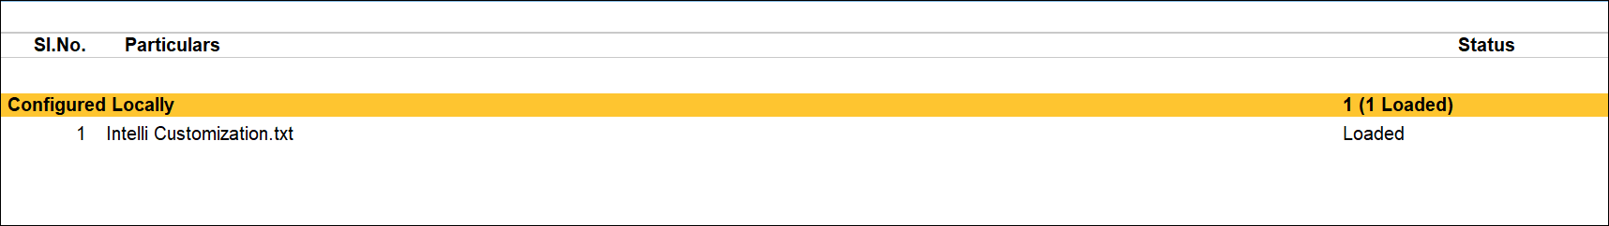

Set “Yes” to the options “Enable Brand wise ledger Price list”
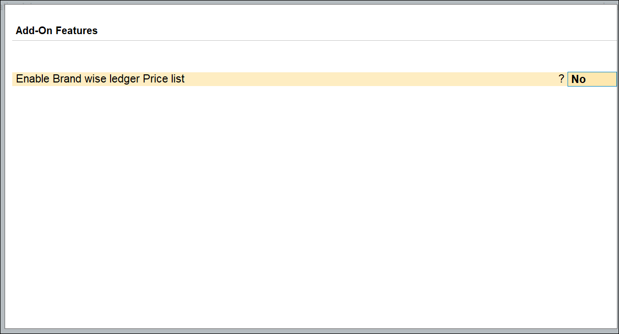

- Go to Gateway Of Tally Brand Setup to create name of brand

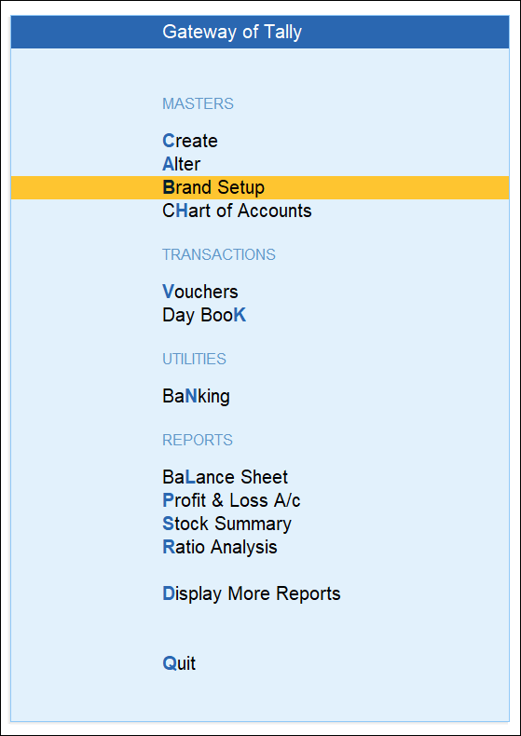

- Creates different Brands

Creating Stock item control and Price list on ledger

- Go to Gateway Of Tally Create/Alter Ledger to specify stock items with brand and prices thereof.

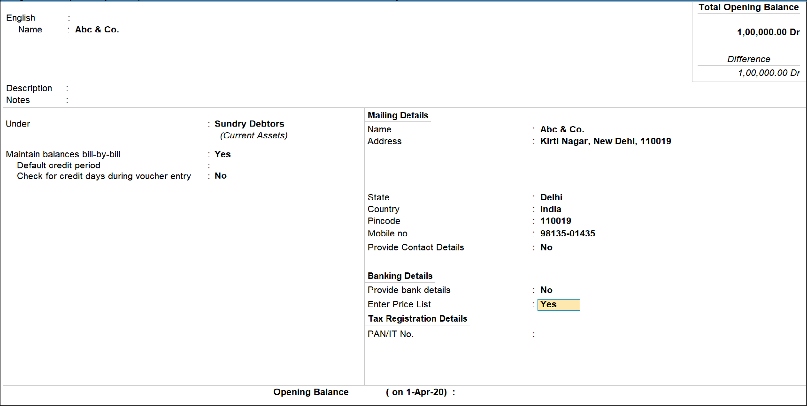

- Set “Enter Price List” to Yes and select brand of the party and enter the “Date of applicability” of prices list:
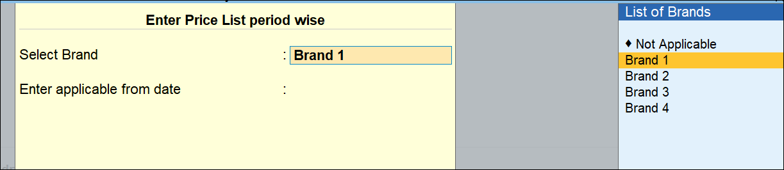
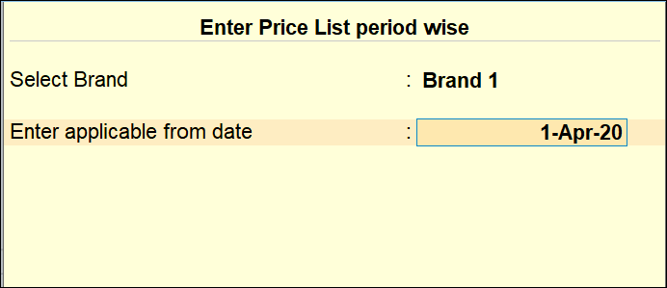

- Enter Stock item, MRP, Discount if any, Selling price:
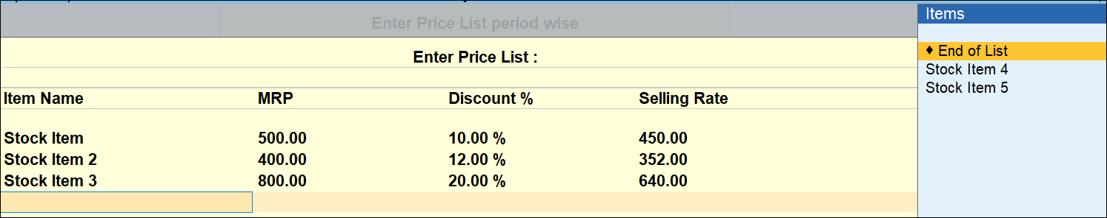

- . Discount is not mandatory - you can use MRP or settled price. It will be picked in sales invoice accordingly.
Note: - You can also sort items. User can issue invoice for Stock items mentioned here only. Only stock items mentioned here will be visible at sales voucher screen.

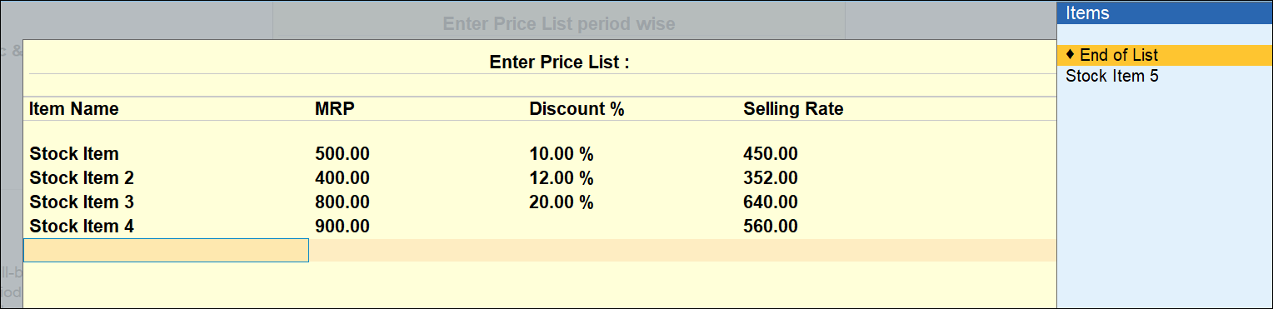

- Enable Sales order features.
- Go to Gateway of Tally Vouchers and create a Sales voucher.
- Enter stock item, here you will be allowed only those stock items which were saved in the ledger at the time of mentioning price list with brands.
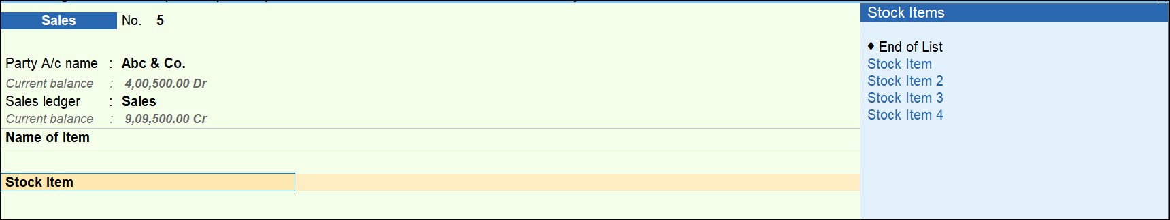

- After entering Quantity in Item allocation screen Rate, Discount and amount will be calculated automatically.

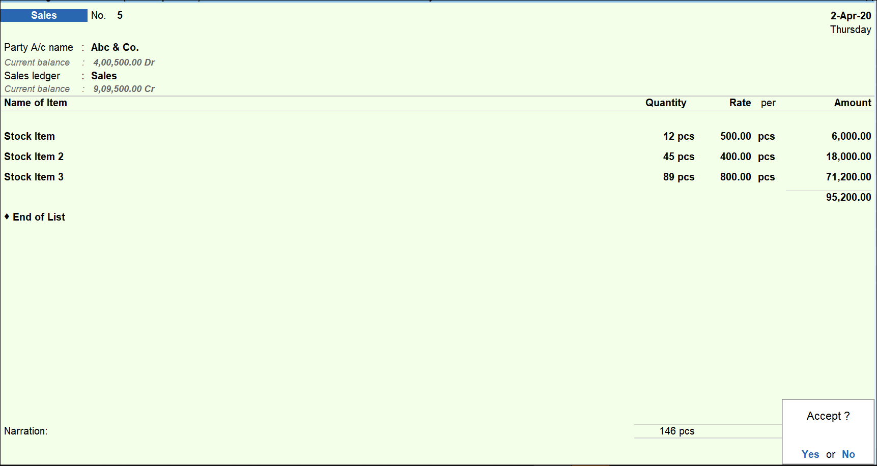

FAQ
Which version/release of Tally Prime does the add-on support?
This add-on will work only from Tally Prime Release 1.0

How will I get support for this add-on?
For any functional support requirements please do write to us on intallysolutions@gmail.com or call us at + 91-9813501438, +91-9991428000. Alternatively, you can send a support query to support@tallysolutions.com.

If I need some enhancements / changes to be incorporated for the add-on, whom should I contact?
Please to write to us on intallysolutions@gmail.com with your additional requirements and we will revert to you in 24 business hours.

Will new features added be available to us?
We offer one year availability of all support and new features free of cost. After one year, nominal subscription cost will be applicable to you to continue to get free support and updates.

What will happen after one year?
A subscription for a year has to be renewed for the Add-On. The cost would be 20% of the MRP prevailing at that time, of the Add-On.

I am using a multi-site. Can I use the same Add-on for all the sites?
No, one Add-on will work only for one site. You need to purchase again if you want to use the same Add-on for more sites.

How do I configure the add-ons for multi-site?
If you are a TallyPrime Multi site user, add the Add-on to the required site as follows:
  - Gateway of Tally F1: Help Settings License Manage Account. This shall open control centre on Tally Portal / Website
  - Go to TDL Management TDL Configuration Select the site’s default TDL
  - Under ‘Select TDL Account’, select the Add-on Name and Click on Create / Accept button.
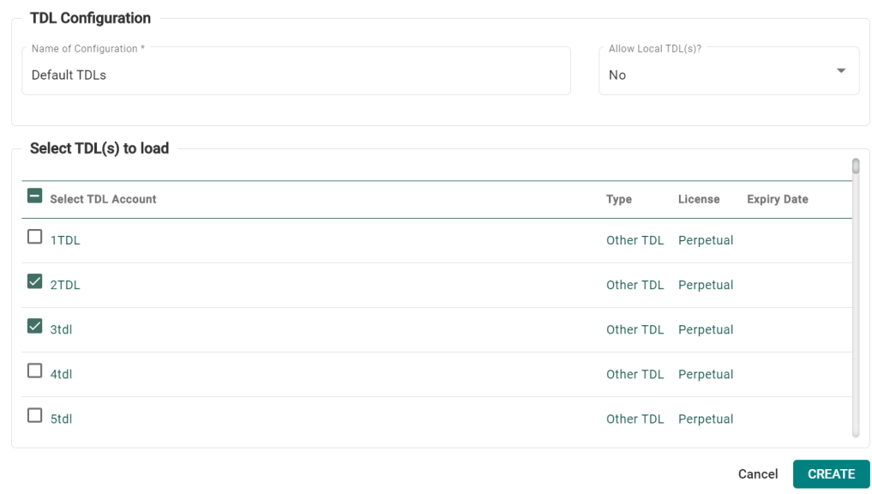
  - Update your license by going to Gateway of Tally F1: Help Settings License Manage License F5: Update

Note: To know or change the site’s default TDL configuration, go to Gateway of Tally F1: Help Settings License Manage Account. In the webpage go to Account Management License Management and look at the Deployment section in the right side of the pane.)

If you face problems in configuring the add-on, click on this link to know more.
http://www.tallysolutions.com/website/html/solutions/how-to-configure.php

I have upgraded to a new TallyPrime Release. What will happen?
Normally, the add-on will work fine without any glitches. If you face problems with the Add-on, you can contact us for support.

TDL Management screen shows errors with the Add-on. What do I do?
Check whether the error is because of the Add-on or because of clashes between 2 TDLs (An add-on is also a TDL). In case of clashes, disable one or more TDLs and check which TDL has the error. If the Add-on has a problem, you can report it to us.

My Tally went into educational mode after installing the add-on. What do I do?
go to Gateway of Tally F1: Help Settings License Manage Account. In the webpage go to Account Management License Management and look at the Deployment section. Select Not Applicable for TDL Configuration and the Add-On is removed for the license. Now Update the license from the product.

How do I cross upgrade the Add-on from Silver to Gold Edition?
Go to F1: Help TallyShop. A web page for TallyShop shall open. Choose the add-on for which the edition needs to be changed. Update the license and restart Tally after download.

My Subscription for the Add-on has expired. How do I renew my subscription?
Go to F1: Help TallyShop. A web page for TallyShop shall open. Choose the add-on for which the subscription is required to be renewed.

Will this add-on work in remote session?
Yes, this add-on will work remotely.

